Database Query Assignment:
Performing Queries using Microsoft Access,

WARNING

This tutorial provides a detailed tutorial on using Microsoft Access, and an introduction to relational database & query concepts. You will need to apply what you learn in the tutorial in the exercises at the end of this document. You will submit your printouts resulting from these exercises to be graded as part of this assignment. There will likely also be questions on your exam relating to topics presented in this exercise. Pay attention to the information introduced and be sure you understand what you are reading & doing during each step. Simply following the steps without reflecting on how you are accomplishing tasks is a path to struggling with the exercises and missing points on the exam. Be sure you learn by doing. Good luck!

Introduction

The purpose of this exercise is to introduce you to techniques used for querying databases. As a manager, you're likely to want to query databases to turn data into information. The query tools in the Microsoft Access database management system provide a great environment for learning more about relational databases and query tools. The next few pages will introduce key concepts, provide you with some introductory exercises, and the final section will list problems to be completed as part of your homework assignment.

Although you'll be using a database created by a particular product, Microsoft Access, the understanding of relational database concepts and query techniques that you'll gain in these exercises can be applied to a wide variety of database systems. In addition, although you're using Microsoft Access as the query tool, many other tools such as Visual Studio .NET and other third party products function very similarly.

Your database contains tables for a fictitious food importer called 'Northwind'. Four of the tables contained in this database are shown in the diagram below (Categories, Products, Order Details, and Suppliers).

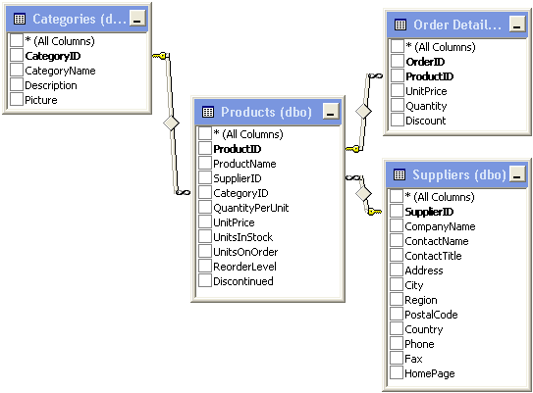

In this database, the Categories table lists information related to the categories of products that the firm sells. The Products table lists information on each product that the firm sells. The Supplier table lists information on each supplier that the firm deals with. The Order Detail table lists the detail of each order (i.e. a record for each item sold, like a line in a receipt).

Like most databases that you are likely to encounter, this database is organized as a relational database. This means that the multiple tables in the database relate to one another via common fields (sometimes referred to as keys). The relations involving common fields are indicated in the diagram by the lines drawn between the tables. For example, the Products and Categories tables relate to one another on the common field CategoryID, the Products and Order Details tables relate to one another on the common field ProductID, and the Products and Suppliers database relate to one another via the common field SupplierID.

Note that the terms 'Record' and 'Row' are used interchangeably to describe a line in the list of data in a table (10 records/rows are shown in the Products table output below). Similarly, the terms 'field' and 'column' are both used to describe the individual data items that make up a record (six fields/columns are shown in the Products Table that follows – ProductID, ProductName, SupplierID, CategoryID, QuantityPerUnit, and UnitPrice).

Understanding Relationships

Consider the relationship between the Products and Suppliers tables. In this example, the 'Products' table contains a single record (row) for each product that your firm offers for sale. A subset of data contained in the Products table is displayed below.

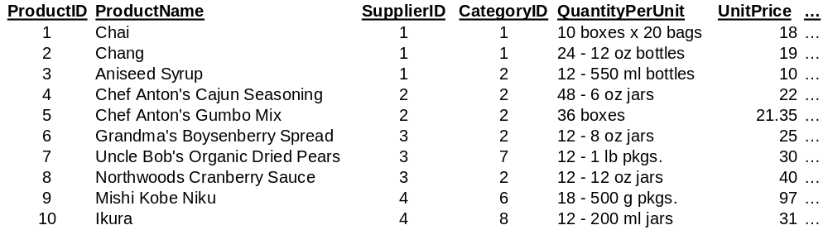

The 'Suppliers' table contains a record for each supplier that your firm deals with. A subset of data from the Suppliers table is displayed below.

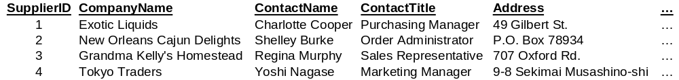

We can join output from these two tables together, matching records in common between the two tables by using the common field SupplierID that exists in each table. Doing so, the ProductName in the Product table is listed along side the appropriate CompanyName field from the Suppliers table. In this way, we can create an output list that displays the appropriate Company and Contact for a given Product, as in the subset of records in the listing below.

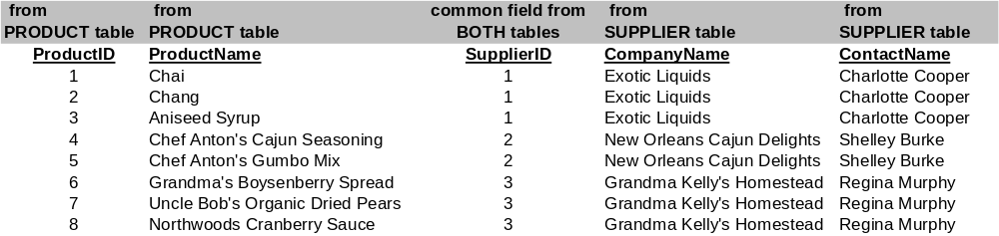

Organizing data this way can be very advantageous. We save hard drive space – for example we don't have to repeat information about the supplier each time we enter a record in the Product table. Instead we just reference an appropriate SupplierID number within each record in the Product table so that it points to a record for the product's Supplier in the Supplier table. More importantly, this type of database is much easier to update. If the company name, address, or contact changes, then only a single record needs to be changed in the Suppliers table. All future queries will reflect this change.

One-To-Many Relationships

When discussing the relationship among tables in a relational database, we sometimes refer to a one-to-many relationship. This means that a single record in one table may be identified as being associated with many records in another table. As an example, consider the relationship between the Suppliers table and the Products table that follows. A single supplier may provide several products. We can say that Suppliers has a one-to-many relationship with Products.

Similarly, Products have a one-to-many relationship with Order Detail. Each Order Detail item indicates a line-item on a given order. A single product may appear in several order detail records across several individual orders. Hence we would say that the Products table has a one-to-many relationship with the Order Detail table. The relationships among these three tables are depicted graphically in the following diagram. If you take further classes in areas such as information systems, computer science, or accounting you may see additional examples of database relationships, however this brief introduction should give you enough background to complete the assignment.

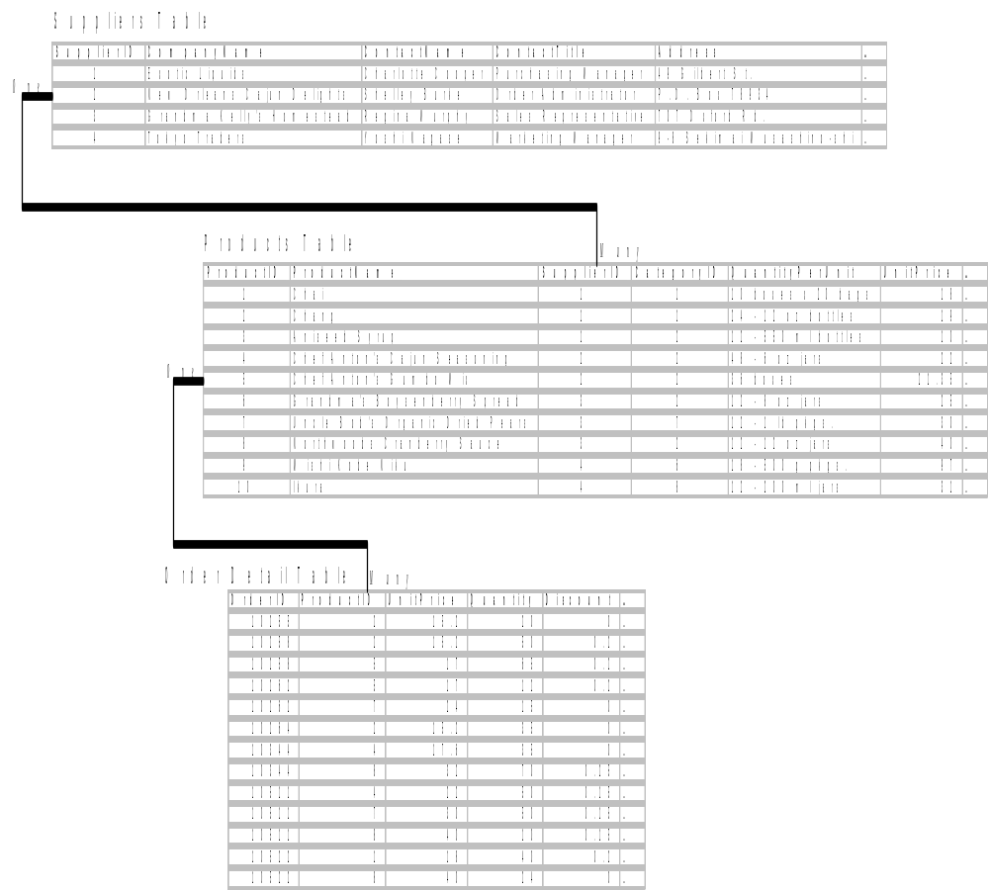

Structured Query Language (SQL) & These Exercises

SQL or Structured Query Language is an industry standard language used for creating, accessing, and manipulating databases. SQL (sometimes pronounced 'sequel') is used by a wide variety of products including some of the most popular database management systems by Microsoft, Oracle, Sybase, and IBM. The query editor in Microsoft Access will automatically generate SQL statements for you. You can learn more about the syntax of SQL by selecting View -> SQL view as you set up your query, but this exercise will not require that you write any SQL code yourself. Learning tip – the SQL view in Microsoft ACCESS is a great way to learn the basics of SQL query statements. For those that want to learn more about SQL (you don't have to), feel free to experiment with statements on your own. A number of web sites such as SQLCourse.com offer online courses for learning SQL. It looks great on a resume! And for those of you wishing to learn more about Access, there are plenty of online course, as well as a great Database class offered here at BC.

Opening the Database

Microsoft Access comes with the Professional Edition of Microsoft Office, so you may or may not have this application installed on your computer. Therefore, it may be necessary to perform this exercise in a computer lab on-campus.
- Download the Northwind database file (Northwind_BC.mdb) from your course's website and double-click the file to open it. Be sure to use the file Northwind_BC.mdb. Do not attempt to use the version of the Northwind database that comes with Microsoft Access. The file on your instructor's site has been modified to work with this exercise.

When you double click on the Northwind_BC.mdb to open it, you will see a dialog box stating 'Security Warning: Unsafe expressions are not blocked. Do you want to block unsafe expressions?'
- Click the 'No' button.
You will receive a subsequent Security Warning stating "This file may not be safe if it contains code that was intended to harm your computer. Do you want to open this file or cancel this operation?"
- Click the 'Open' button.

Examining the Database

On the left side, you will see the all the objects in that make up a Microsoft Access database: tables, queries, forms, reports, pages, macros, and modules. In this exercise, we will work with tables (files or lists of information) and queries (structured methods to request information from one or more tables).
- Click on the Tables button to view a list of tables in the database.
You should see a window that looks like the one below,

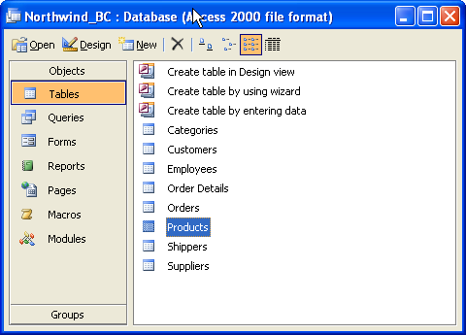

Note: The screenshots that follow will assume that you've maximized your Northwind database window. If you haven't, simply click the maximize icon in the Northwind_BC window to expand the window to its full size.

Opening a Database Table

Let's take a quick look at the contents of the 'Products' table.
- Double-click on the Products table. You will see a window like the one below.

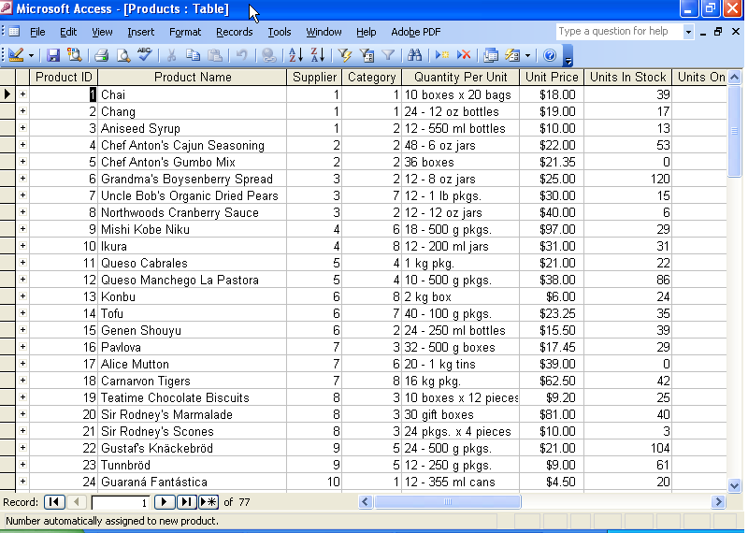

This table stores the list of products that Northwind sells and characteristics of those products, such as product name, price, inventory levels, etc. Each row represents a record in the table and each column represents a field in the table.
- Close the Products table by selecting File -> Close (not Exit).

Opening a Query & Viewing the Design View

Before we create a query to organize information from the tables in our database, let's look at an existing query.
- In the list of database objects, click on the Queries button to view a list of queries that have already been created.

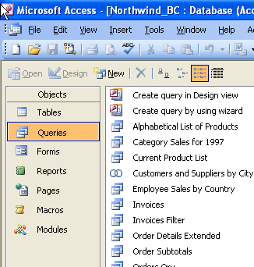

- Highlight the query called ‘Alphabetical List of Products’ and click the Open button.
As you probably expected, you now see an alphabetical list of products (your window should look something like the one displayed below, although the window below is abbreviated somewhat to make the document easier to read). The window displaying query output is called the Datasheet View.

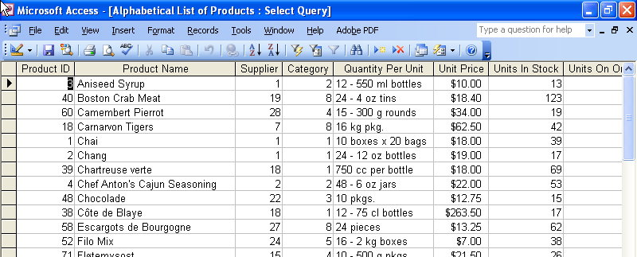

- To see how this query was designed, select View -> Design View.

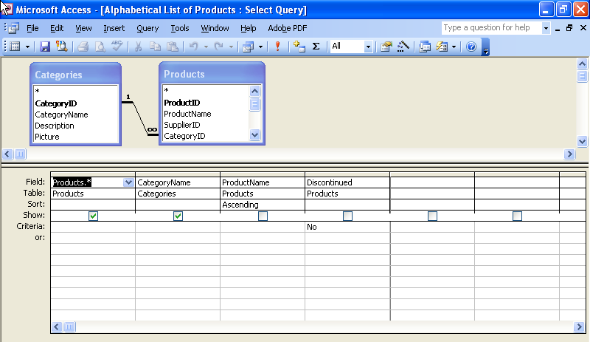

The Design View is the area where you can graphically set up a query. Looking at the Design View for this query will give you a sense of how to set up a query to display a selection of items from a database. The design view for this query shows the tables and the fields involved in the query. This query uses the Categories table and the Products table. The (Products.*) in the first column of the 'field' row indicates that all of the fields from the Products table are used in the query (the '.*' followed by a table name tells Access to include all of the fields in that table). The query also displays the ‘CategoryName’ field from the Categories table. Note that the check mark in the 'Show' row indicates that these fields are shown. The query also sorts the data by ‘ProductName’ in ascending order (A to Z) and filters out discontinued products by selecting all fields where 'Discontinued' in the 'Products' table equals the value 'No'. But even though these fields are used as part of the query, they are not shown (hence the 'Show' box for these fields is not checked.
- Close the query by selecting File -> Close (not Exit).

Creating a Simple Query

Let's create a simple query to display the ‘ProductName’ and ‘UnitPrice’ fields from the Products table. Make sure the Queries button in the Objects pane is selected.
- Double-click the icon called ‘Create query in Design view’.
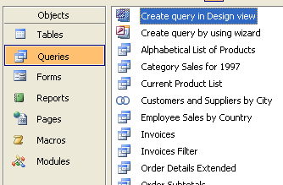
The Show Table dialog box will display.

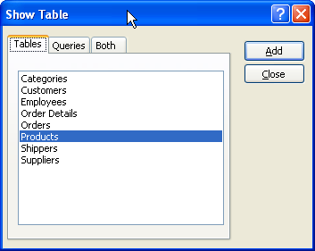

- Highlight the ‘Products’ table and click the Add button.
- Click the Close button.

You'll return to the Design View query builder & your screen will look like the one below.
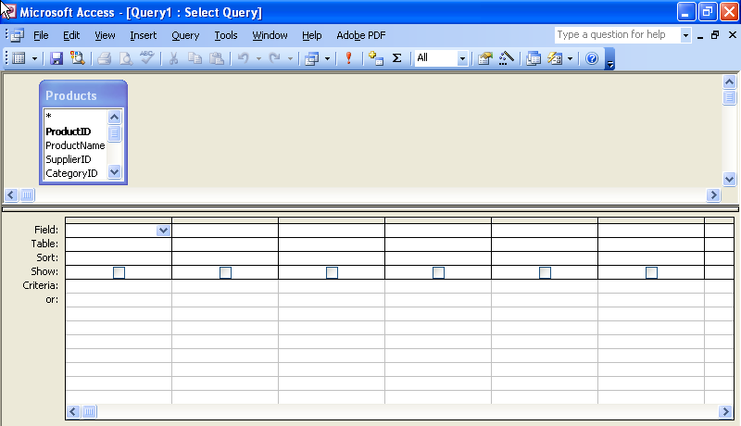

- From the ‘Products’ table, add the ‘ProductName’ and ‘UnitPrice’ fields to the query by double-clicking on those fields. You may have to scroll down the list of fields in the 'Products' table to view 'UnitPrice'. If you prefer, you may also drag these fields from the table to the lower half of the query window.

- There are several ways to run the query that you have created. You can select View -> Datasheet View or you can select Query -> Run. Use one of these methods to run your query.

You should see two columns of data: one for the product name and the other for the unit price.
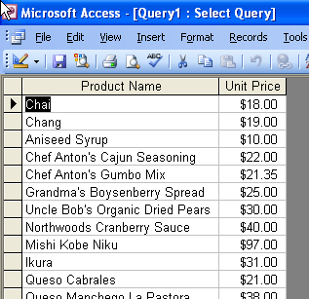

So in the exercise above you used Access to Create a Query in Design View. You selected the Products Table to show in the Design View, then added the Product Name & Unit Price from this table. Pretty easy, eh? The output you created was simply a list. Now let's see how to sort that list!

Sorting Output

Let's modify the output so that it is sorted by unit price, largest price to smallest (descending order).
- Go back to the design view by selecting View -> Design View.
- In the column with the ‘UnitPrice’ field, place your cursor on the third row labeled Sort. Use the drop-down list to change the value to Descending.

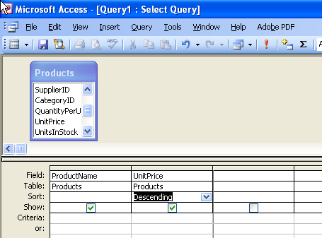

- Select Query -> Run to view the results.

Your output should be sorted on Unit Price, from highest to lowest (descending order).
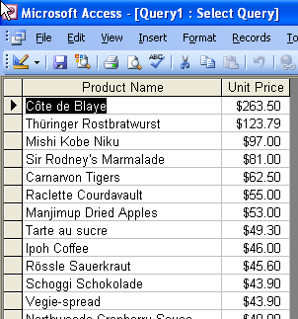

Relational Queries

Now let's add a second table to our query so that we may include the product category name.
- Go back to the design view by selecting View -> Design View.
- Select Query -> Show Table...
- Double-click the ‘Categories’ table to add it to the query.
- Click the Close button to close the Show Tables dialog box and return to the Design View.
Notice that Microsoft Access automatically linked the tables using the ‘CategoryID’ field, the common key between the two tables.

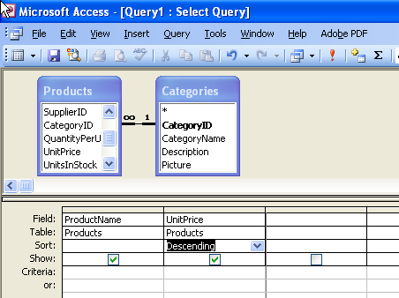

Next, let's add the ‘CategoryName’ field from the ‘Categories’ table to the query.
- Double-click the ‘CategoryName’ field from the field list for the 'Categories' table.

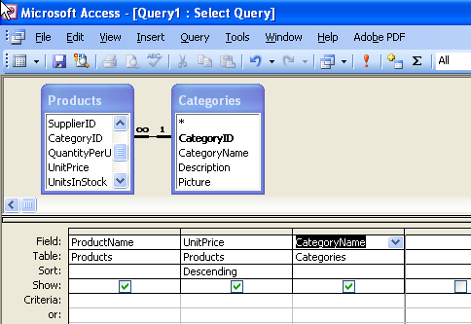

- Select Query -> Run to view the results.

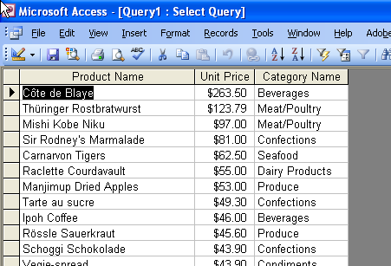

You've just completed a query of two tables related on a common field (in this case CategoryID). Access used this field to automatically show the Category Name from the Categories Table for each Product Name in the Products Table.

More complex Queries

Now let's add the supplier name from the ‘Suppliers’ table to our query.
- Go back to the design view by selecting View -> Design View. Select Query -> Show Table...
- Double-click the ‘Suppliers’ table to add it to the query.
- Click the Close button to close the Show Tables dialog box.

You can move the boxes that represent the tables by dragging them by their respective title bars. Rearrange the tables so that the Products table is in the middle. Notice that Microsoft Access automatically linked the ‘Products’ table to the ‘Suppliers’ table using the ‘SupplierID’ field. (The ‘Products’ table was already linked to the ‘Categories’ table via the ‘CategoryID’ field.)

- Add the ‘CompanyName’ field from the ‘Suppliers’ table to the query by double-clicking the ‘CompanyName’ field in the 'Suppliers' table field list.

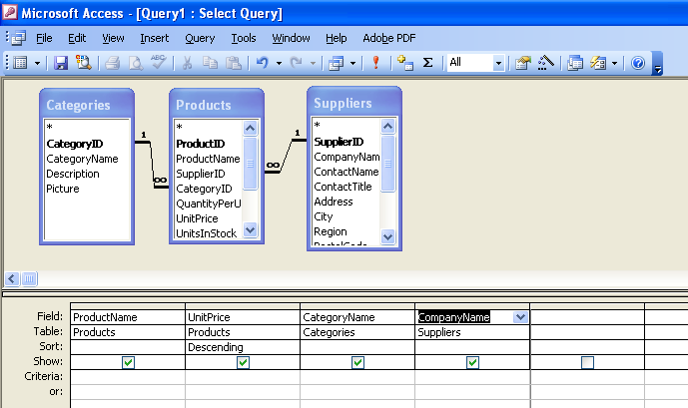

- Select Query -> Run to view the results.

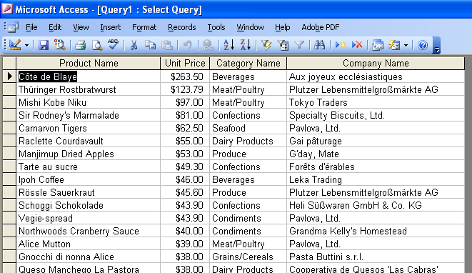

The Group By Clause

Up until this point, all results returned by the database have displayed individual records. In this next example, you'll learn how to create queries that aggregate (group) records. Grouping records can be useful, particularly if you want to perform a mathematical operation on several records such as find an average, sum, or record count. In this example, let's imagine that you'd like to find out the average price for products in each category.

First, let's get rid of the old query we created above and create a new one displaying UnitPrice and Category Name.

- Go back to the design view by selecting View -> Design View.
- Get rid of the query by selecting File -> Close.
- When asked if you'd like to save changes to the query, select 'No'.
You will be returned to the Northwind_BC : Database window.
- Make sure the Queries button in the Objects pane is selected. Double-click the icon called ‘Create query in Design view’.
The Show Table dialog box will display.
- Double click the ‘Products’ table to add it to the Design View.
- Double click the 'Categories' table to add it to the Design View, too.
- Click the 'Close' button to close the 'Show Table' dialog box.

Add UnitPrice & CategoryName
- Double click 'UnitPrice' from the 'Products' table field list to add it to the query. You may have to scroll to find the 'UnitPrice' field.
- Double click 'CategoryName' from the 'Categories' field to add it to the query.

- To get a sense for why the Group By clause is helpful, first Select Query -> Run to view the results of the query we just created.
Notice that Categories are shown multiple times. Each record represents one product of that Category in the Category table (we aren't showing the ProductName, but there really is one record for each Product). Let's assume you want to compare the Categories by their average UnitPrice. This is where the 'Group By' clause comes in.

- Select View -> Design View to return to the Design View.
- Select View -> Totals to display the 'Total' row in the Design View. Note the 'Total' row appears as the third row from the top, with 'Group By' listed in each cell under the field names.
- In the ‘UnitPrice’ column, click the 'Group By' label to expose a dropdown list and select Avg.

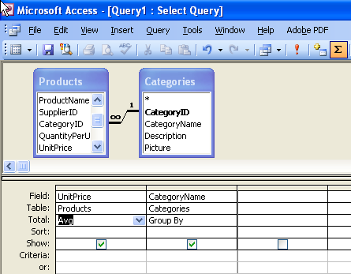

You've just told Access to group the query results by CategoryName and get an average for each Category.

- Select Query -> Run to view the results.

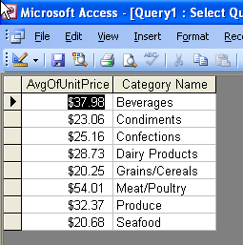

Not bad – you're seeing how to turn data into information & answer a question! We don't need this query anymore, so feel free to discard it:
- Select File -> Close to close the query. There is no need to save the query.

Setting Criteria to Limit Output

We can also set up queries to select a subset of records for display in the Datasheet view. Let's assume that you want to create a query listing all of the products sold from the supplier named Tokyo Traders.

- Make sure the Queries button in the Objects pane is selected. Double-click the icon called ‘Create query in Design view’.
The Show Table dialog box will display.
- Choose the ‘Products’ table and the ‘Suppliers’ table.
- Add the ‘ProductName’ field from the ‘Products’ table and the ‘CompanyName’ and ‘SupplierID’ fields from the ‘Suppliers’ table.
- In the ‘CompanyName’ column, enter Tokyo Traders for the criteria. Be sure to spell it correctly. Note, if you press the 'Tab' key or click outside of the cell, Microsoft Access will automatically add quotes around the words – this is OK.

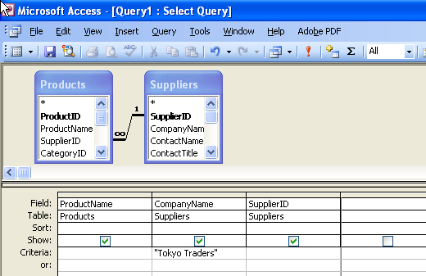

- Select Query -> Run to view the results.

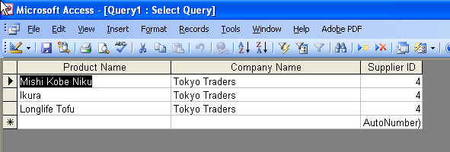

You should notice that only those products from Tokyo Traders show up in the Datasheet view. Also note that you could also limit the query output by ‘SupplierID’ rather than ‘CompanyName’. Let's try this technique to limit the output to those products supplied by the supplier with the SupplierID equal to 4 (New Orleans Cajun Delights).

- Go back to the design view by selecting View -> Design View.
- Erase Tokyo Traders from the ‘CompanyName’ criteria (be sure you erase everything from this field, including any quotation marks).
- Enter =2 in for the ‘SupplierID’ criteria. Note that Microsoft Access does not add quotes around numbers.

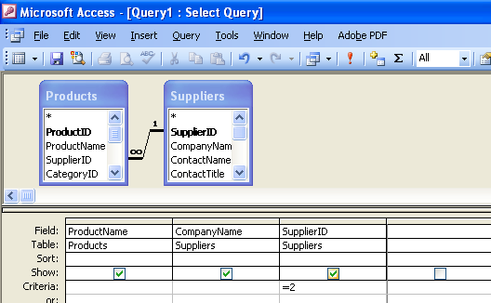

- Select Query -> Run to view the results.

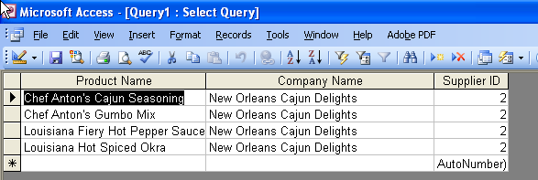

You should notice that only those products supplied by New Orleans Cajun Delights (supplier number 2) show up.

Also recognize that you can set multiple criteria by using the 'Or…' rows. To show all products that are produced by either supplier with SupplierID equal to either 2 (Cajun Delights) or 3 (Grandma Kelly's) add the following to the query you just created.

- Go back to the design view by selecting View -> Design View.
- In the row under the first criteria (=2), enter the number =3.

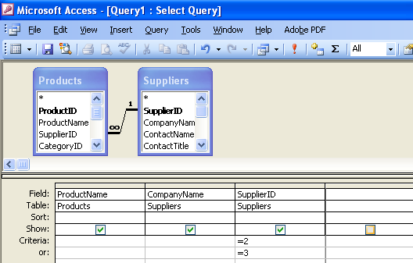

- Select Query -> Run to view the results.

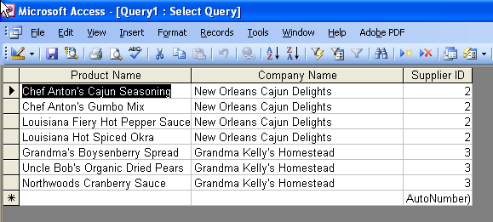

Note that the Datasheet view now shows listings from Grandma Kelly's Homestead in addition to those products from New Orleans Cajun Delights. You can experiment with values in the Criteria field. Note that in addition to the = operator, you can also enter > (greater than), >= (greater than or equal to), < (less than), <= (less than or equal to), and <> (not equal to). You may need to use these other operators for the Homework exercises.

Finally, note that we can still query selecting on criteria in the SupplierID field, but we can hide this field from display in the query results. To do this:
- Return to the Design View by selecting View -> Design View.
- Click the check box to remove the check in the 'show' row of the SupplierID field.
- Select Query -> Run to view the results.

Note that the query results remain the same – limited to New Orleans Cajun Delights and Grandma Kelley's Homestead, but the SupplierID is hidden from the output.

- Select File -> Close to close the query. There is no need to save the query.

Performing Additional Calculations in Queries

While the Group By clause showed how you can perform calculations on a particular field (say getting an Average of the UnitPrice field), it's also possible to perform calculations across fields. In the example below, we'll create a query that lists the Product Ordered and also calculates the total ordered for that product by multiplying the UnitPrice field by the Quantity field (both of these fields are in the Order Details database – there's also a 'Discount' field in this table, but for simplicity purposes in our exercises, we'll ignore the discount). We'll do this first showing the total each time a product was ordered; then we'll modify the query to sum up the total for each product.

- Make sure the Queries button in the Objects pane is selected. Double-click the icon called ‘Create query in Design view’.
The Show Table dialog box will display.
- Choose the ‘Products’ table and the ‘Order Details’ table, then close the 'Show Table' dialog box.
- Add the ‘ProductName’ field from the ‘Products’ table to the query.

Calculate UnitPrice multiplied by Quantity and put it in a column named 'SubTotal'. This is fairly easy – we'll just use the '*' expression to multiply items together, just like you do in Excel. But here's where it gets a bit tricky – there are two UnitPrice fields in the tables in the Design view (this isn't the best practice, but we'll work with it). One UnitPrice is in the Products table, and one is in the Order Details table. As it turns out, the UnitPrice field in the Order Details table is the one that we want. In order to distinguish which field in which table we want, we'll preface our fields with the name of the table.
- In the empty column to the right of the ‘ProductName’ field, enter the following: SubTotal: [Order Details].[Quantity]*[Order Details].[UnitPrice]. Be sure you type this exactly as it's written, paying attention to which letters are lower vs. upper case.
- Sort the data from largest subtotal to smallest (descending order).
Your query should look like the one below (I've expanded the SubTotal column so you can see the entire calculation). Note that the name SubTotal was taken from the first part of your calculation (before the ':' character). This is how you can name a calculated field in your output.

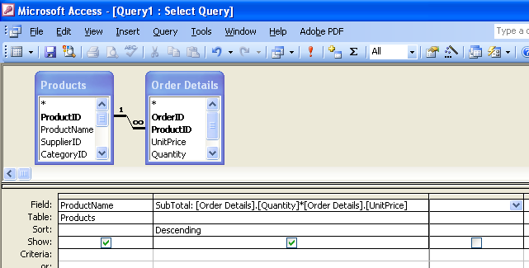

- Select Query -> Run to view the results.
Your results should look like the ones below. If your query does not run (e.g. you're presented with an error message or a dialog box asking you to type in a field), then you've entered your SubTotal calculation incorrectly. Be sure to pay attention to spaces & upper/lower case when typing your SubTotal (and in a pinch you can even copy & paste the text from above, although you may need to use the SubTotal technique again in your assignment).
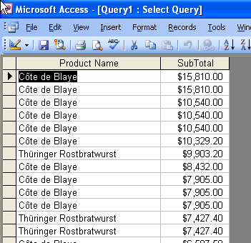

The query you just entered shows the UnitPrice x Quantity each time an item was ordered. Skeptics can easily verify Quantity and Unit Price were correctly multiplied together by adding these two fields to the query. If you'd like to do this, go back to Design View and just double-click on the ‘UnitPrice’ and ‘Quantity’ fields in the ‘Order Detail’ table. These steps will add these fields to the output. Then run the query again. You'll be able to see the UnitPrice and Quantity next to the SubTotal field you created, and you can perform a quick calculation to see that your results have indeed been processed correctly. Neat, eh? If you decide to do this check of your work, make sure you remove these fields before continuing on with this exercise.

While showing the Total (UnitPrice x Quantity) per item ordered is nice, it may be more practical to sum up the total orders for each ProductName. You already know how to do this using the Group By clause. Let's give this a try.
- Select View -> Design View to return to Design View.
- Select View -> Totals to display the 'Group By' row.
- In the SubTotal column, change the Total from Group By to Sum. This will sum up the UnitPrice*Quantity calculations for each ProductName.

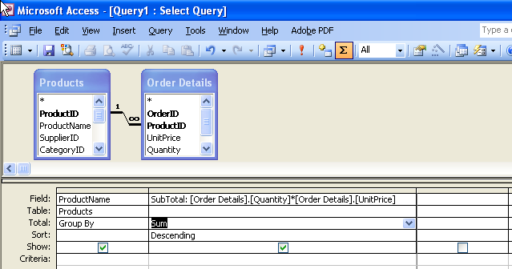

- Select Query -> Run to view the results.

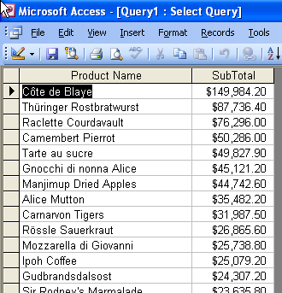

Congratulations – you now have a strong understanding of how to extract data from a relational database & turn it into information. This is an extremely valuable skill – may it bring you riches, renown, and the admiration of peers and recruiters alike!

Homework

Open Excel. For each question below, enter the following on a new worksheet in cell A1, A2, and A3 respectively: 'Name', 'Section:', and 'Question #', then enter your full name in cell B1, your section # in cell B2, and the Question # in cell B3. After completing each exercise below, highlight the results from the Datasheet View in Microsoft Access (simply click on the leftmost column and drag across to the right to select all of the columns), select 'Copy' from the 'Edit' menu, and paste them into the Excel spreadsheet starting at cell A5. Widen the columns so that the data in each column can be read. Print out the results, staple the output together, and hand in. You should be submitting 5 sets of output in total, each of which correctly identifies you, your section #, and the problem # at the top of the listing.

NOTES: when completing the assignments below, you may find it helpful to refer to the diagram on the second page of this tutorial that shows the various tables and the fields contained within those tables.

I strongly suggest that you close any existing query before beginning the assignment and that you close each query after it has been completed and run and you have transferred your output to Excel (to close the query, select 'Close' from the 'File' menu). You should do this to make sure that you're starting fresh with each query and that you aren't influencing the query with any selections made from a previous query. You can save the queries to your database files if you'd like, particularly if you need to see the TA later with problems (if you're working in the campus computer labs, you can keep any changes you've made to your database file by e-mailing your database file to yourself or saving it to a myfiles location at wfs.bc.edu).

- Assume that you need a report on products offered by the suppliers with ‘SupplierID’ 5, 6, and 7. Create a query that lists only all of those products sold by suppliers 5, 6, and 7. The first column in the output in the Datasheet view should list ProductName, the second should list ‘CompanyName’. Do not list the SupplierID in the output. Sort the records on ‘CompanyName’ using an Ascending Sort (A-Z).

- Assume that you need a report showing products that have a list price of $50 or more. Create a query that lists all products with a list unit price of greater than or equal to $50. Output should list ‘ProductName’, ‘CompanyName’, and ‘UnitPrice’ (Note: there are two ‘UnitPrice’ fields, one in the Product table, one in the Order Details table. In this example use the ‘UnitPrice’ in the Product table – we'll assume this is the list price). Order the products from most expensive to least expensive.

- You want to find out which suppliers have generated the most sales for your firm. For simplicity, let's assume that the fields 'UnitPrice' times 'Quantity' (both in the Order Details table) indicate the price that a particular item was sold at (i.e. you can ignore the Discount field and any other numeric fields, and should ignore the ‘UnitPrice’ in the Product table). Create a query that lists two columns: ‘CompanyName’ and a field named 'Total Sales' that lists the total sales of all products offered by that Company. Sort the results from largest Total Sales to smallest. Hint: Use the Group By clause and make sure that the Design view shows all tables necessary to establish the necessary relationships needed to relate this data (i.e. do you see a line relating the tables containing the fields that you need? If not, do you need to add an additional table to relate them?).

- You want to find out which products are most popular and which firms supply them. Create a query that will produce results listing four columns: ‘ProductName’, ‘CompanyName’, ‘CategoryName’, and a field that totals the number of a particular product that has been ordered. Sort the list from the most popular products to the least popular. Hints: Use the Group By clause and be sure to consider the fact that the Quantity item of the Order Detail table lists how many of a particular item was ordered (e.g., so you'll want to sum up this Quantity field).

- Create a query that displays the number of products offered from each supplier. The results should display a row for each supplier, listing the supplier's ‘CompanyName’ followed by a column that counts the number of products offered by that supplier. Sort the suppliers from the largest number of products to the smallest. Hint: Use the Group By clause and look for 'Count' in the drop-down where you've previously set up 'Avg' and 'Sum'.

© Copyright John M. Gallaugher, Ph.D, Last Updated April 17, 2007.
Some of these exercises were in part adapted from the book "Visual Interdev 6 from the Ground Up" by Joseph O'Neil, published by Osborne Press.
If it helps you to consider this in business terms, then for purposes of this exercise assume ‘UnitPrice’ in the Products table is a list price, while ‘UnitPrice’ in Order Details is the actual price at the time of sale. Since we're interested in the actual sale price, we'll ignore the list price and instead calculate the sale price of each item using the ‘UnitPrice’ and Quantity fields, both from the Order Details table.

